# 

### **CS3606:: Advanced JavaScript for web and web applications**

# 

# 

# 

# 

# 

# Lecture 7

## **Exercises sheet**

## **Aristos Markogiannakis**

## 

## **Please use these notes together with my lecture presentation.**

**Exercise 1**

The first exercise is an exercise to get a bit of understanding why we need Asynchronous programming in JavaScript.

During this exercise you will need to copy the code from the steps below try to understand what is wrong and discuss them with your lecturer and your classmates.

**Step 1:**

Copy the html code in a folder called example1

Name the file example0.html

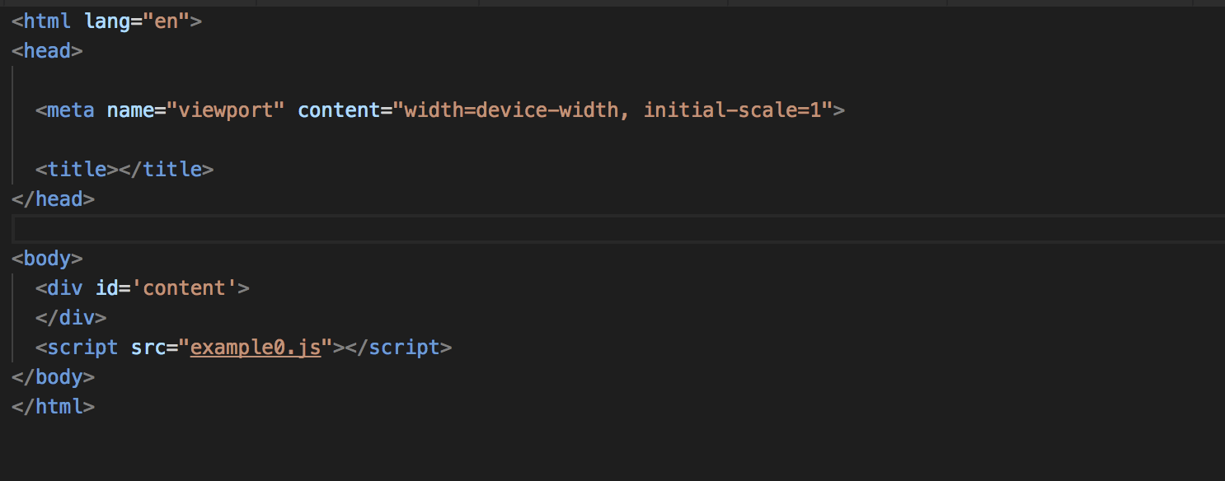

**Step 2:**

1. Create a javascript file copy this file at the root folder at the same location as the example0.html

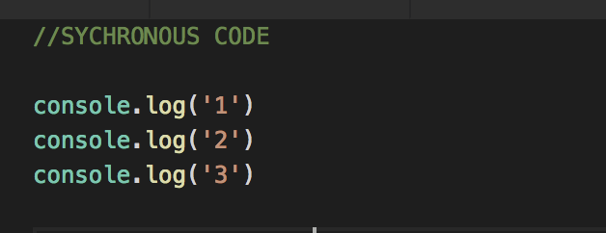

b) Remove the previous code and add this code.

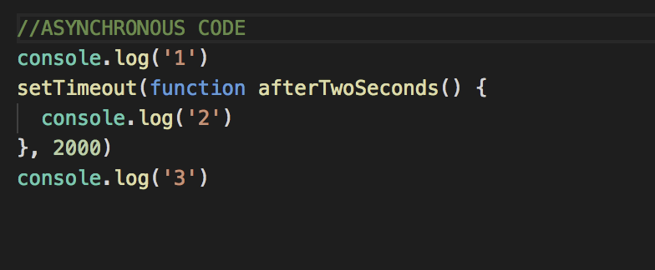

**Result:**

Let’s discuss what are the difference between **a)** and **b)**.

**Exercise 2**

1. **What is wrong with the code below?**

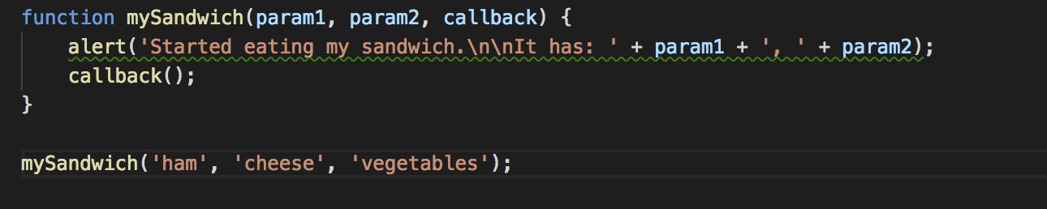

**b) What is needed in order to print your name**

cb({user: “Aris”});

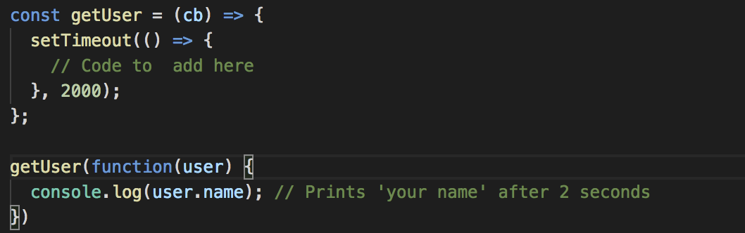

c) Add the code needed to do what is shown on the comments

